**1. Executive Summary**

This report describes the conformance of <https://www.pcbox.com/> with [W3C’s Web Content Accessibility Guidelines (WCAG)](https://www.w3.org/WAI/standards-guidelines/wcag/). The review process is described in Section 5 below and is based on evaluation described in [Accessibility Evaluation Resources](https://www.w3.org/WAI/eval/).

Based on this evaluation, https://www.pcbox.com/ **meets** WCAG 2.0, Conformance Level AA. Detailed review results are available in Section 6 below. Resources for follow-up study are listed in Section 7 below. Feedback on this evaluation is welcome.

**2. Background about Evaluation**

Conformance evaluation of web accessibility requires a combination of [semi-automated evaluation tools](https://www.w3.org/WAI/ER/tools/) and manual evaluation by an ‘experienced reviewer’. The evaluation results in this report are based on evaluation conducted on the following date(s): 23/10/2020. The website may have changed since that time.

**3. Scope of Review**

* PC BOX
  + Computer Store
* https://www.pcbox.com/
* https://www.pcbox.com/ ;   
  https://www.pcbox.com/categorias/ordenadores-sobremesa?nodo=53
* It was excluded from the analysis any other page of the website.
* 23/10/2020
* Spanish

**4. Reviewer(s)**

* Michael Burri
* I.E.S. Francisco Ayala
* tecumseh1993@gmail.com
* ‘IT expert’
* Spanish/English

**5. Review Process**

* WCAG 2.0 Level AA
* https://www.tawdis.net/

**6. Results and Recommended Actions**

* + This website appears to meet WCAG 2.0 AA
  + Accessibility features in which this site is strong include: Use of color, mínimum contrast, text images, keyboard availability, focus guidance, text resizing, headers and titles, consistent navigation and identification, errors prevention, proccessing, and name, function and value.
  + Recommended priorities for addressing inaccessible features are: Page language, page titles and non-textual content.

**7. References**

* [Web Content Accessibility Guidelines (WCAG) Overview](https://www.w3.org/WAI/standards-guidelines/wcag/)  
  https://www.w3.org/WAI/intro/wcag
* [Web Content Accessibility Guidelines 2.1](https://www.w3.org/TR/WCAG20/)  
  https://www.w3.org/TR/WCAG21/
* [Techniques for WCAG 2.1](https://www.w3.org/WAI/WCAG21/Techniques/)  
  https://www.w3.org/WAI/WCAG21/Techniques/
* [Accessibility Evaluation Resources](http://www.w3.org/WAI/eval/)  
  http://www.w3.org/WAI/eval/
* [Web Accessibility Evaluation Tools List](https://www.w3.org/WAI/ER/tools/)  
  https://www.w3.org/WAI/ER/tools/
* [Using Combined Expertise to Evaluate Web Accessibility](https://www.w3.org/WAI/eval/reviewteams)  
  https://www.w3.org/WAI/eval/reviewteams

**8. Appendices**

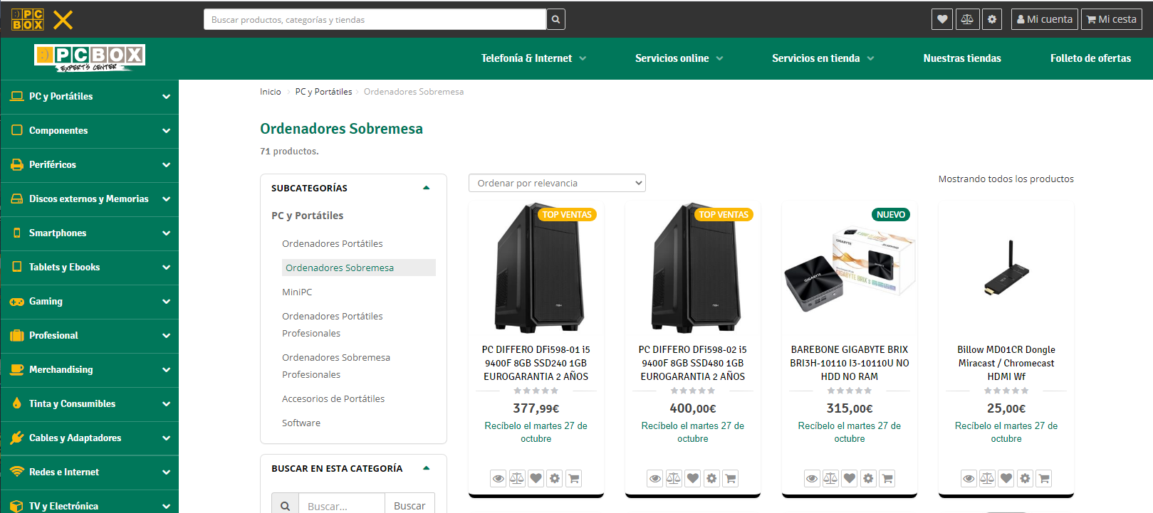

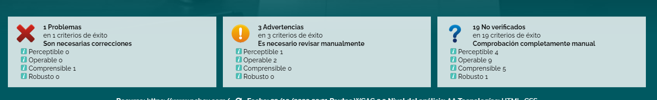

[TAWDIS] Detalle del análisis https___www.pcbox.com_.pdf